# Required Components

|  |  |
| --- | --- |
|   **1**  **3**  **2** | **BILL OF MATERIALS**  **1**  Boppin’ Beaver Linkimal  **2**  Mono jack  **3**  Wire |

# Required Tools

* Drill with ¼” drill bit
* Wire Strippers
* Flush Cutters
* Phillips screwdriver
* Soldering Iron
* Solder
* Ruler

# Required Personal Protective Equipment (PPE)

* Safety Glasses

# Assembly Instructions

## Step 1

Cut 2 lengths of wire about 11cm long. Strip 0.5cm of the insulation off each end of the wire.

**x 2**

## Step 2

Solder a wire to the first leg of a mono jack, solder a second wire to the second leg of the mono jack.

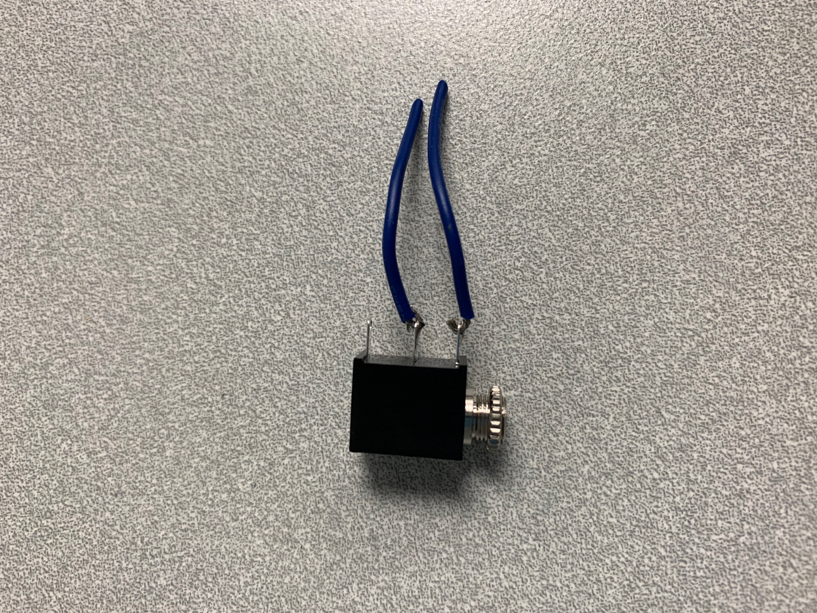

## Step 3

Carefully take the Boppin’ Beaver out of the packaging without damaging it. The toy will be put back in the packaging once adapted.

|  |  |
| --- | --- |
|  |  |

## Step 4

Remove the 4 screws from the body of the beaver including the one hidden in this picture by the beaver’s tail.

## Step 5

Disconnect the white speaker wire that is holding the 2 halves of the beaver together. Set the half of the beaver with the head attached aside.

## Step 6

Drill a ¼” hole in the side of the beaver.

## Step 7

Remove the 2 screws holding down the circuit board. Remove the turquoise switch and set it aside.

## Step 8

Solder the other ends of the wires attached the mono jacks to the locations shown below.

## Step 9

Remove the nut from the mono jack and push the mono jack through the hole from the inside. Reinstall the nut and tighten to secure the mono jack.

## Step 10

Reinstall the turquoise switch and screw in the 2 screws into the circuit board.

## Step 11

Reattach the speaker wire and screw in the 4 screws into the back of the beaver.

## Step 12

Put the Boppin’ Beaver back into the original packaging.

|  |  |
| --- | --- |
|  |  |